American International University-Bangladesh
Faculty of Science and Information Technology
Department of Computer Science
OBJECT ORIENTED PROGRAMMING 1 (JAVA)

Semester: Summer 2019-20

Student ID | Student Name | Sec
20-42091-1 | Md. FORHADUL ISLAM | AA
20-42268-1 | NABILA CHOWDHURY JOYA | AA

- Project Title: Student Management System.

- Project Description: We have used total eight Java class to create this
System. Every classes has described below this line.

1. Faculty
For Teacher (variable) | For Student (variable)
Public String Name  Public String course  Public String email | public String studentName  public String studentId  public String studentcourseName  public String studentAddress  public String studentPhonNumber
For Teacher (Method ) | For Student (Method)
Faculty()  Faculty(String Name, String course, String email)  void setName(String Name)  void setCourse(String couse )  void setEmail(String email)  String setName()  String setCourse()  String setEmail() | void setData(String studentName, String studentId, String course, String address, String number)  void setStName(String studentName)  void setStID(String studentId )  void setStcoursel(String studentcourse)  void setStAdd(String address)  void setphone(String phone)  String getStName()  String getStID()  String getStcoursel()  String getStAdd()  String getphone()  Void getData().

2. Student
Faculty Allstudents[]=new Faculty[200]

Faculty facultys[]=new Faculty[12]

void insertFaculty(Faculty f)
void insertFaculty(Faculty f)
void ShowAllfaculty()

void insertStudent(Faculty S)
void removeStudent(String ID)
searchStudent(String ID)
void ShowStudent()

- This class is totally abstract class

3.Exam
public abstract void midterm()
public abstract void show()

4.Mid extends Exam
int a, score=0
void finalterm()

void midterm()

void show()

5.Final extends Mid.
int b,mark=0 ; char x;
void finalterm();

void show()

- Both of this are interface class .

6. CGMid | 7.CGFinal
double MidTerm() | double FinalTerm()

8.Count implements CGMid, CGFinal

double MidTerm()
double FinalTerm()

- you. Project Features:
In our programming, we have created multiple options for

1.You can add multiple faculty in our program.
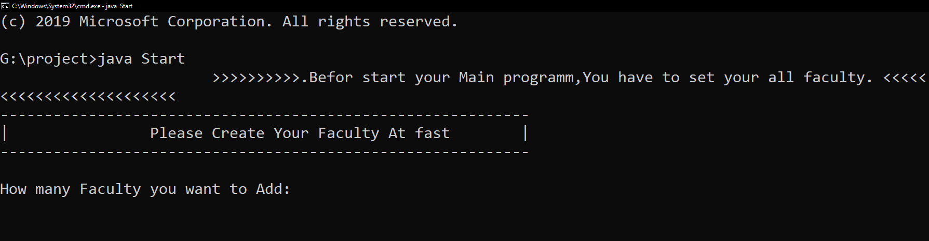

2. After added faculty we will be entering the main part of the program.
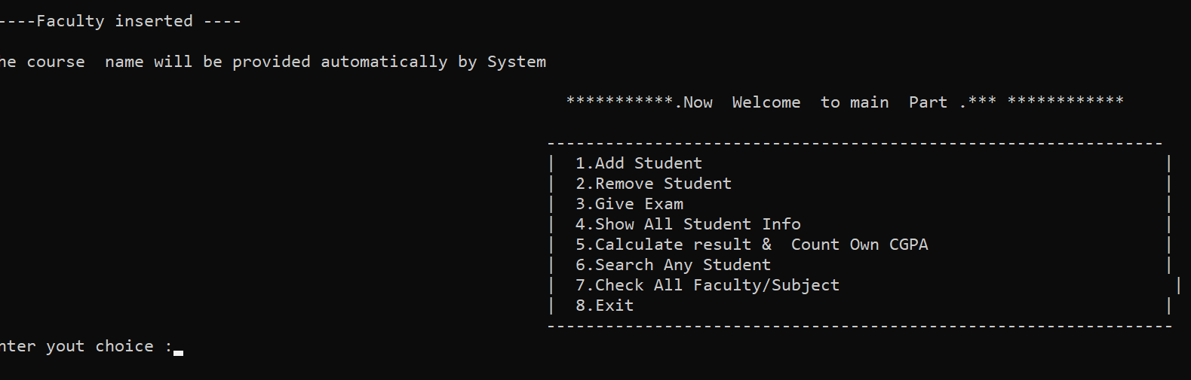

Our menu looked like this. Here program has waiting for your command. As we can seen here is created multiple options for you.
- You can Add Any Student in any faculty.
- You can remove any student from any faculty.
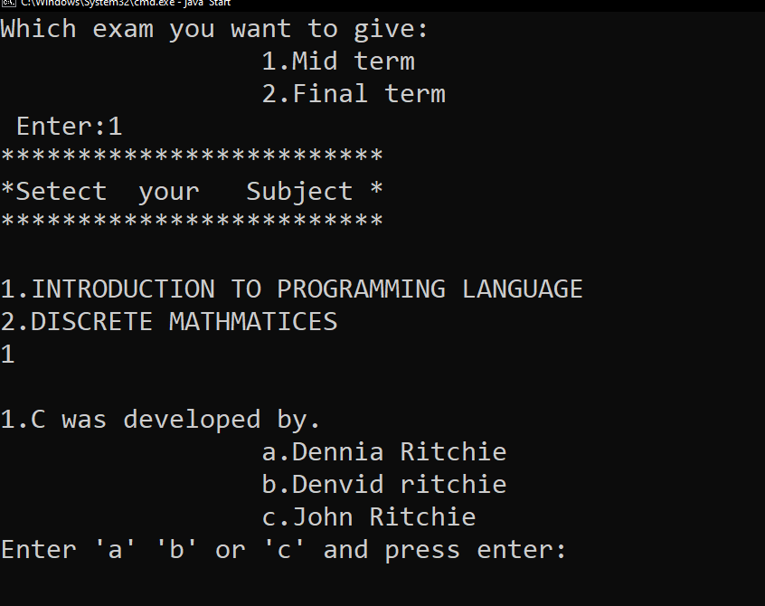
- Any Student can give an exam if he/she wants and the exam will be taken by quiz systematically.

- You can see all student information
- You can find out any student information by searching id.

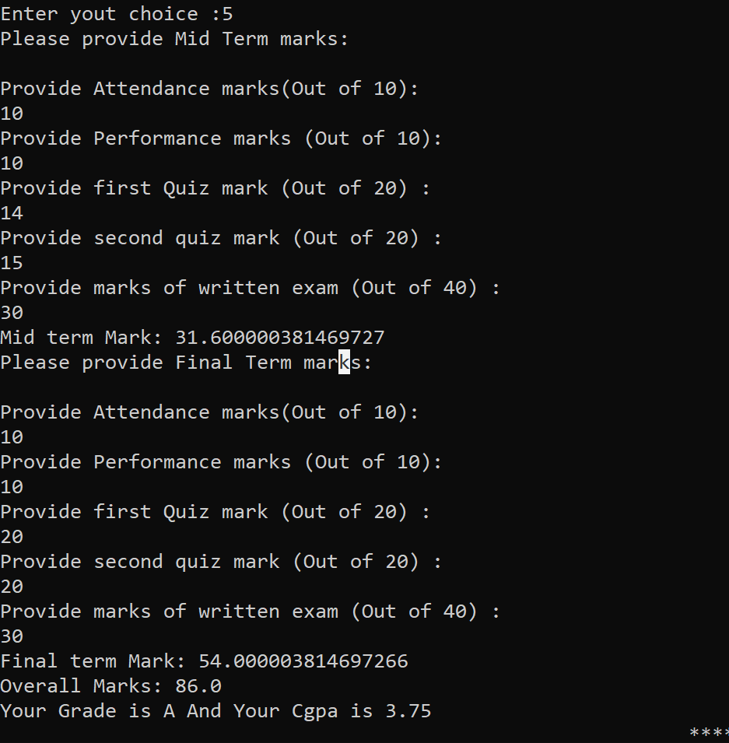
- You can count your own CGPA. Like this ->

- You also can see how many faculty you have.
- Then if you want then you can take exit of this system .

